**Eligibility File Processing**

**Production server details:** COAUAPPPRD049

**To get the processed file report:** COAUSQLCRM006.CRM_MSCRM

**Step-1:** Run the console application for each client id one by one.

* Update the config file with client id and run the console application.

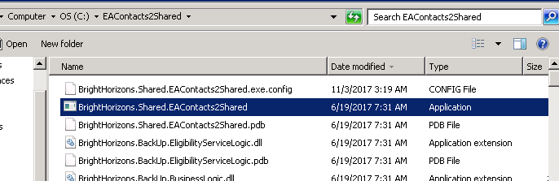

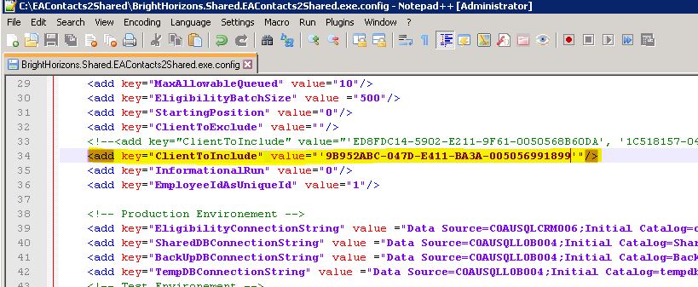

**Step-2:** Drop the file from eligibility mapping template to bh_import

* EMT folder path:

F:\Eligibility Mapping Templates

* Drop folder path: to drop the files

C:\bh\bh_import

* PreProcessing folder path: to check the file status

C:\bh\PreProcessing

* Log file path: to check the logs in Yalv! (please select all files while adding the log file into yalv)

C:\bh

**Step-3:** Validate the processed file report from “COAUSQLCRM006.CRM_MSCRM” by running the below query in current date ( a previous day to our date)

Select bh_company, bh_companyName, Createdon, bh_deletes, bh_inserts, bh_updates, bh_totalrows

from COAUSQLCRM006.CRM_MSCRM.dbo.bh_eligibilityHistory h

where convert(date, CreatedOn) >= '11/2/2017'

order by h.Createdon

**Step-4:** Send the mail to the group with processing status. Place the updated file in same location.

User : 99904264

Pasd : Apr@2018

Preeti VM: 10.36.96.26

User :brighthorizons\97004408

Pch04408

<https://bhvpn.brighthorizons.com/dana-na/auth/url_default/welcome.cgi>